**Front End Engineering II**

**Project Report**

**Semester-IV (Batch-2022)**

**Tic Tac Toe using Tailwind CSS**

**Supervised To-: Submitted By-:**

**Mr.Raveesh Samkaria Sneha Chaudhary**

**2210990857**

**G-13(A)**

**Department of Computer Science and Engineering**

**Chitkara University Institute of Engineering & Technology,**

**Chitkara University, Punjab**

# 

**Table of Content-:**

|  |  |  |
| --- | --- | --- |
| **S.No** | **Title** | **Page.No** |
| **1** | **Abstract** | **1** |
| **2** | **Significance** | **2-3** |
| **3** | **Problem Statement** | **3-4** |
| **4** | **Software Requirements** | **5** |
| **5** | **Project Design** | **6** |
| **6** | **Methodology** | **7-18** |
| **7** | **Results** | **19** |
| **8** | **Conclusion** | **20** |
| **9** | **References** | **21** |

# **Abstract:**

The Tic Tac Toe game project aims to provide an engaging and interactive experience for players while showcasing the capabilities of Tailwind CSS, a utility-first CSS framework. Tailwind CSS offers a pragmatic approach to styling web applications, focusing on utility classes for rapid development without sacrificing flexibility or maintainability.

The project will feature a modern and responsive user interface designed using Tailwind CSS classes, ensuring seamless accessibility across various devices and screen sizes. Through the integration of Tailwind's utility classes, the game interface will exhibit clean and intuitive design principles, enhancing user experience.

Introduction:Welcome to the world of Tic Tac Toe, where simplicity meets strategy and fun! In this fee project, we embark on a journey to develop a classic game that transcends generations, while harnessing the power and elegance of Tailwind CSS, a utility-first CSS framework.

Tic Tac Toe: A timeless game loved by all ages, Tic Tac Toe pits two players against each other in a battle of wits and tactics. The game is played on a 3x3 grid, where players take turns marking their symbols (traditionally 'X' and 'O') in empty cells. The objective is simple: be the first to align three of your symbols horizontally, vertically, or diagonally.

# 

**Significance**:

1.)Learning Programming Concepts: Tic Tac Toe is a relatively simple game that can be implemented using various programming languages. It serves as a great project for beginners to learn programming fundamentals like variables, loops, conditionals, functions, and data structures.

2.)Problem-Solving Skills: Implementing the logic of Tic Tac Toe requires breaking down the game into smaller problems and devising solutions for them. This helps developers improve their problem-solving skills, an essential trait in software development.

3.)Algorithm Design: Developing an efficient algorithm to determine the best moves in Tic Tac Toe is a common challenge. Implementing algorithms like minimax or alpha-beta pruning for an AI opponent can deepen understanding of algorithmic concepts.

4.)User Interface Design: Creating a user-friendly interface for the game introduces developers to concepts of user experience (UX) and user interface (UI) design. It involves elements like layout, graphics, user interactions, and feedback.

5.)Testing and Debugging: Debugging code and ensuring its correctness is a crucial aspect of software development. Building Tic Tac Toe provides ample opportunities to practice testing techniques and debugging skills.

6.)Version Control: Working on a project like Tic Tac Toe encourages developers to use version control systems like Git. Learning how to manage code changes, collaborate with others, and maintain project history is invaluable for professional software development.

7.)Open Source Contributions: Many Tic Tac Toe implementations are available as open source projects. Contributing to such projects provides exposure to real-world development workflows and collaboration within a developer community.

8.)Portfolio Building: Completing a Tic Tac Toe project allows developers to showcase their skills and creativity in their portfolios. It serves as tangible evidence of their abilities to potential employers or collaborators.

# **Problem Statement:**

Outline the specific requirements that the Tic Tac Toe game must meet. This could include aspects such as:

The game must provide a grid for the Tic Tac Toe board.

Players must be able to make moves by selecting cells on the grid.

The game must detect when a player has won or when the game ends in a draw.

Options for restarting the game or quitting should be provided.

If implementing an AI opponent, specify the level of difficulty or the algorithm to be used.

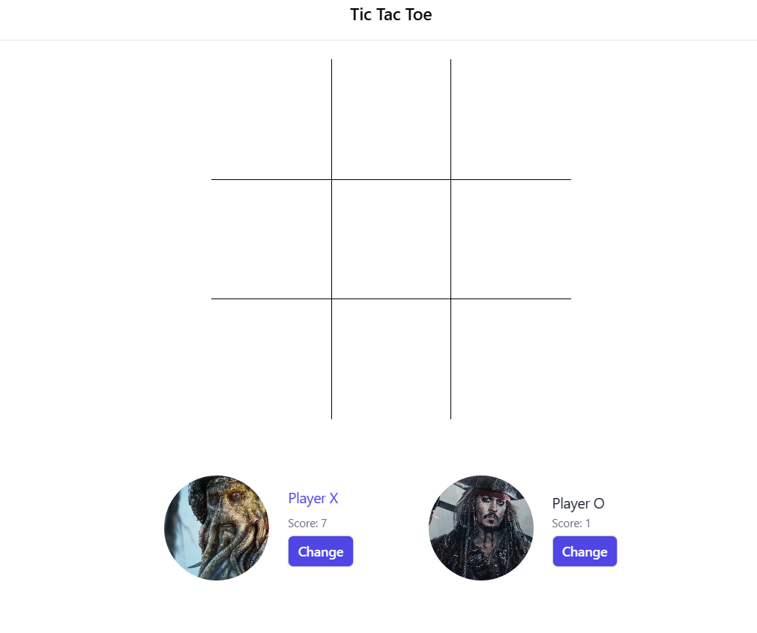

# 

# **Software Requirements:**

The following are the requirements for the project:

## **HTML:**

HTML serves as the foundational framework for web pages, encompassing elements enclosed within tags to delineate content and layout. Adherence to standards and validation are imperative for HTML documents, guaranteeing correct syntax, structure, and cross-browser and cross-device compatibility.

## **Tailwind :**

Tailwind CSS stands out as a prominent utility-first CSS framework, simplifying the styling of web applications. In contrast to conventional CSS frameworks dependent on pre-built components, Tailwind adopts a highly adaptable approach by furnishing an extensive library of utility classes. These classes cover a wide range of CSS properties, including margins, paddings, flexbox, and others, empowering developers to swiftly prototype and style their applications without the need for custom CSS authoring.

## **JavaScript:**

JavaScript plays a pivotal role in web development, primarily serving as a client-side scripting language. It empowers developers to craft dynamic and interactive web pages by dynamically manipulating the Document Object Model (DOM) in response to user interactions. JavaScript grants developers the capability to dynamically access and alter HTML elements and attributes, facilitating a myriad of tasks including content updates, element creation and removal, as well as styling adjustments triggered by user actions or events.

# **Project Design:**

## **Project Overview:**

The objective of this project is to create a responsive website featuring a blurry loading effect using Tailwind CSS. HTML will be employed to structure the content, while Tailwind CSS will handle the visual presentation, ensuring a seamless and captivating experience for users across desktop and mobile devices.

## **File Structure:**

The project will utilize a well-organized folder structure for efficient management and future updates.

* **index.html:** Main HTML file containing the overall website structure and content.
* **index.js:** JavaScript file containing minor interactive elements.

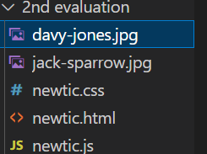

**Methodology:**

The following shows the use of HTML, JavaScript of the project.

**HTML Code:**

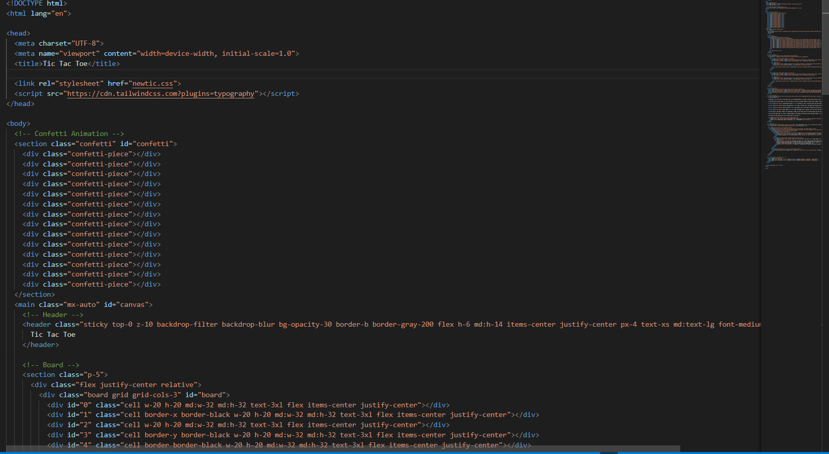

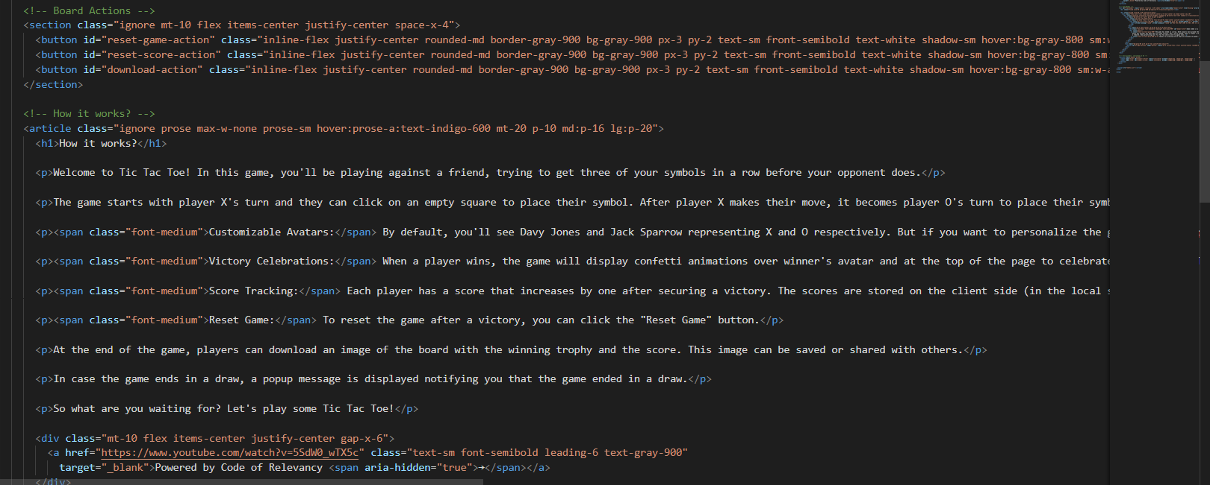

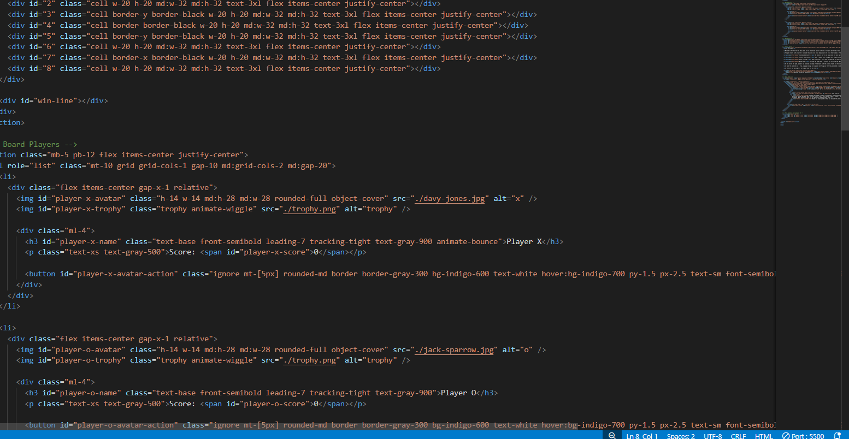

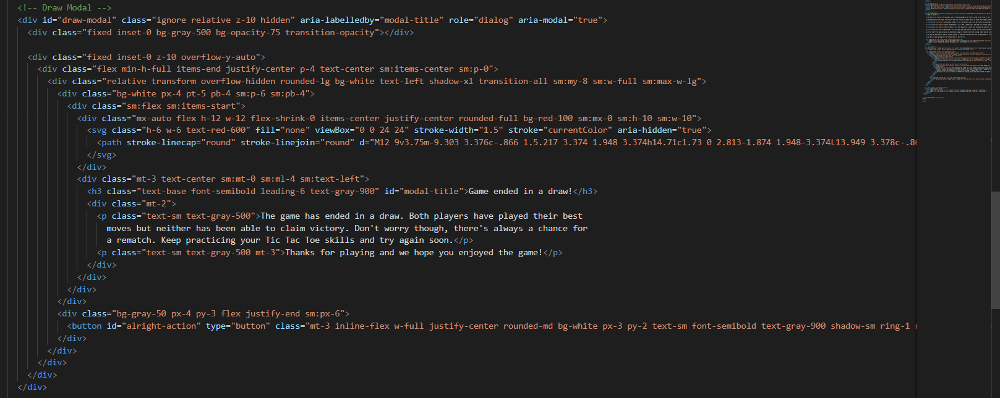

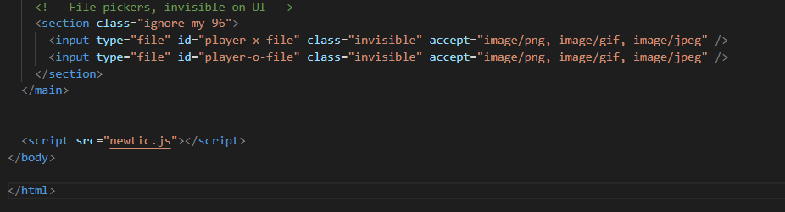**Fig 1.1 :- HTML Code (Tic Tac Toe Game)**

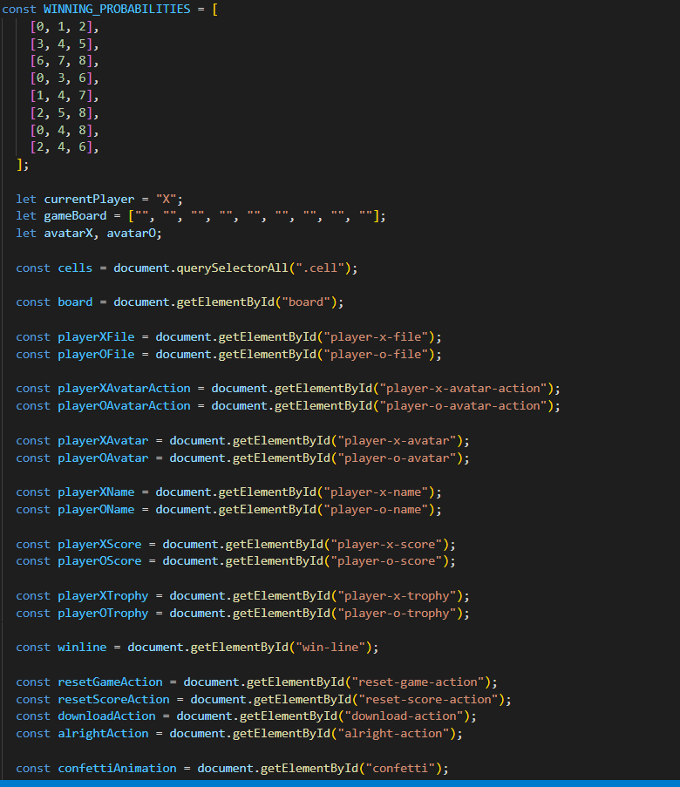**Fig 1.2:-Java Script Code**

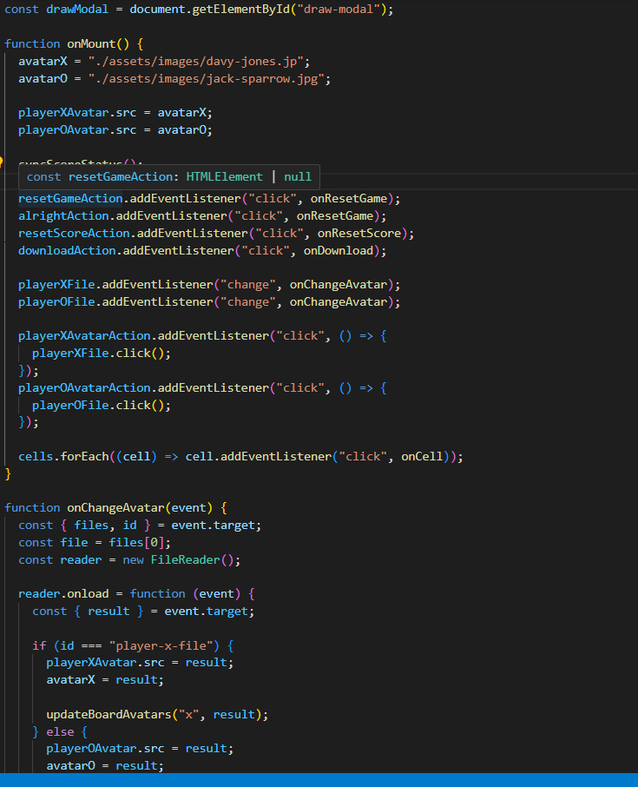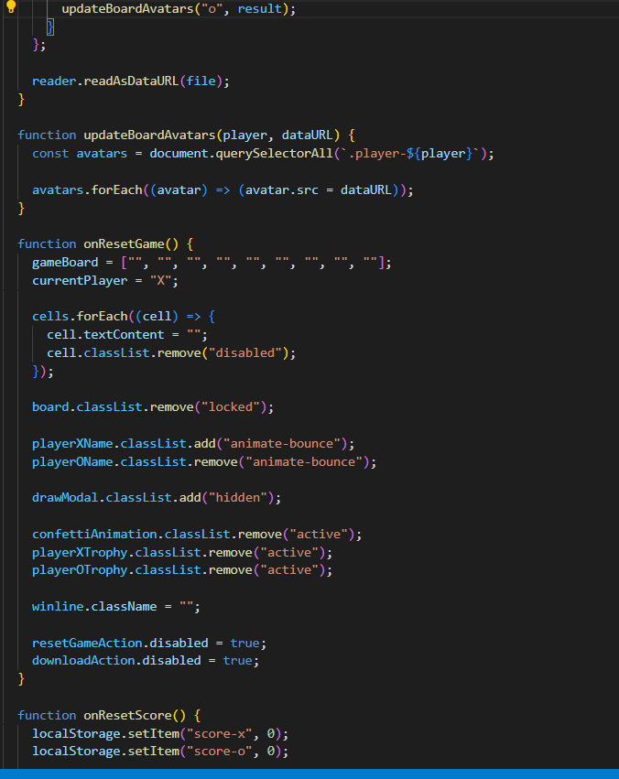

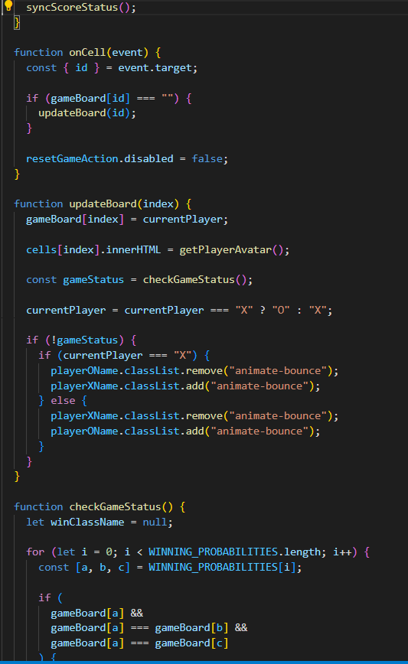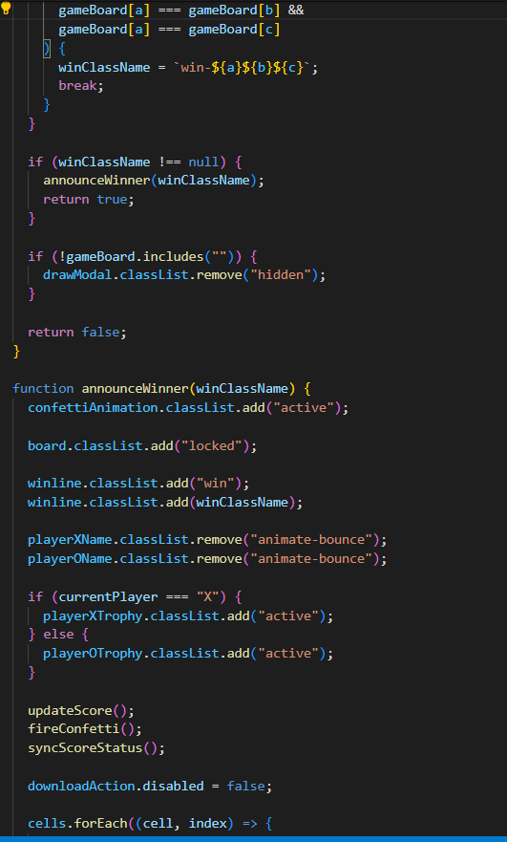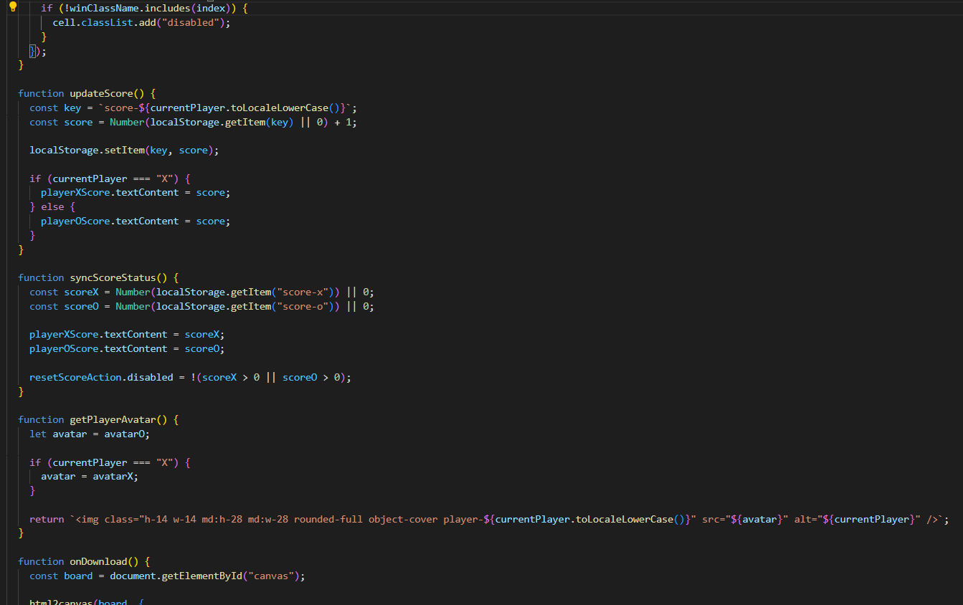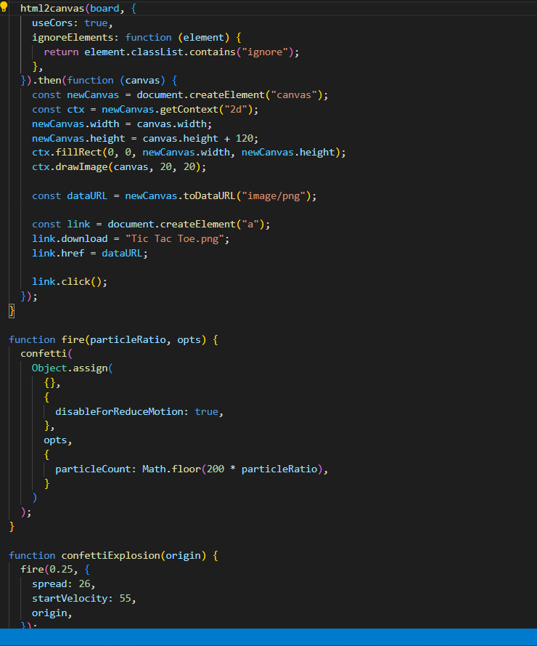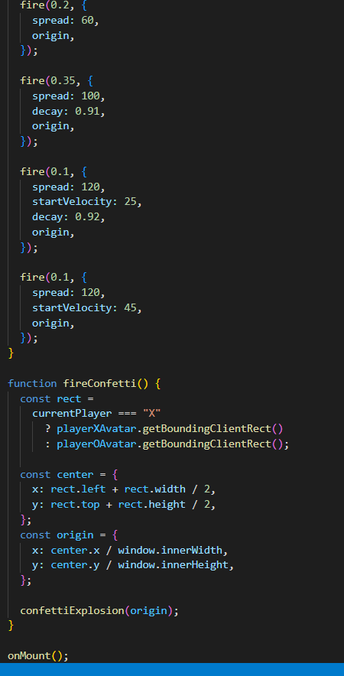

**Fig 2.2 JavaScript Code for Tic Tac Toe Game**

**CSS CODE-**

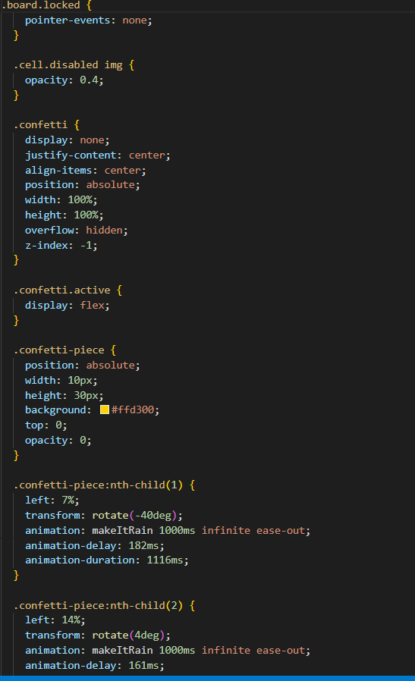

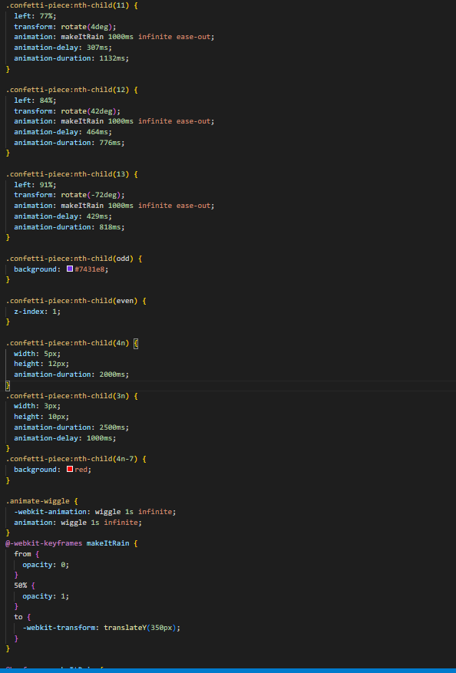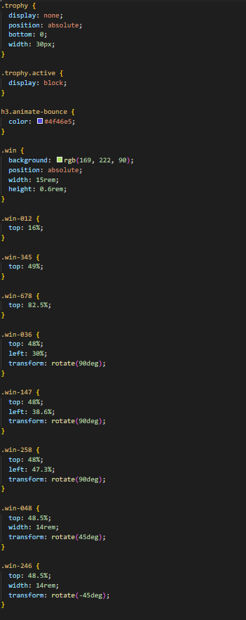

**Results:**



**Fig 3.1 :Before Look! Button is clicked.**

# 

**Fig 3.2 :After Look! Button is clicked.**

# **Conclusion:**

In conclusion, the implementation of a responsive website with a tic tac toe using Tailwind CSS represents a significant step towards enhancing user experience and engagement. By leveraging HTML for content structure and Tailwind CSS for visual presentation, the project has successfully achieved a user-friendly

# **References:**

* Tailwind CSS Documentation:<https://tailwindcss.com/docs>
* Pinterest - For Images :<https://in.pinterest.com/search/pins/?q=coding%20background%20image&rs=typed>
* W3Schools - JavaScript:<https://www.w3schools.com/js/>
* W3Schools - HTML and CSS Tutorials: <https://www.w3schools.com/html/default.asp>